# Power BI Reports Documentation

This documentation provides a comprehensive guide for managing, using, and updating the Power BI reports developed for **UNICEF Canada**. It includes detailed information on the structure of the reports, underlying data logic, measures, and step-by-step guides for maintenance, navigation, and updates.

**Overview of Reports**

The Power BI project consists of 15 reports. These reports provide valuable insights into campaign performance, donor behaviour, and revenue generation.

**Reports**

1. **Renewal Program Revenue Year-Over-Year**
2. **Renewal Program Revenue Year-Over-Year by Channel**
3. **Pledge OTG Revenue Year-Over-Year by Channel**
4. **Renewal Program Revenue Year-Over-Year by Language**
5. **Pledge OTG Revenue Year-Over-Year by Language**
6. **Campaign Performance Summary**
7. **Campaign Performance Year Over Year Summary**
8. **Campaign Performance by Channel**
9. **Campaign Performance Summary: Pledge Donor Acquisition**
10. **Campaign Performance by Package: Renewal Tests**
11. **Campaign Performance Summary with Types**
12. **Renewal Program Actuals vs Budget**
13. **Attribution Summary: One-Time Gifts (no Pledge Gifts)**
14. **Attribution (Indirect) Revenue by Appeal Category**
15. **Campaign Performance Summary by Segment with Attribution**

**Key Features**

**Campaign Dates**

* Campaign dates are fetched directly from the Data Warehouse (DWH).
* The earliest date or the first-row date for each campaign represents the campaign's timeline in the reports.

**Campaign Name Standardization**

* Campaign names are standardized by searching the AppealDescription column in the **DIM Appeal** table (e.g., "H1" or "House 1").
* The **Campaign Name** column links the Budget and Cost tables and ensures consistency across reports.
* Naming conventions are applied dynamically via a DAX query but are also manually aligned in Budget and Cost tables for accuracy.

**Filters**

* SG by package category is not excluded by default but can be customized through the filter panel.

**Navigating the Reports**

* **Filter Panel**: Use the filter panel to apply criteria like year or campaign.
* Selecting a year (e.g., **2022**) dynamically updates all the visuals, including gross revenue, average gift, campaign performance by gift code, and appeal type metrics for the chosen year.
* • The Campaign Name filter at the top allows users to select a specific campaign (e.g., House 1 - Renewal).
* When a campaign is selected: All visuals on the page update to display data for that particular campaign within the selected year.
* Metrics such as Gross Revenue, Average Gift, Percent Revenue, and performance by language or gift code reflect only the selected campaign

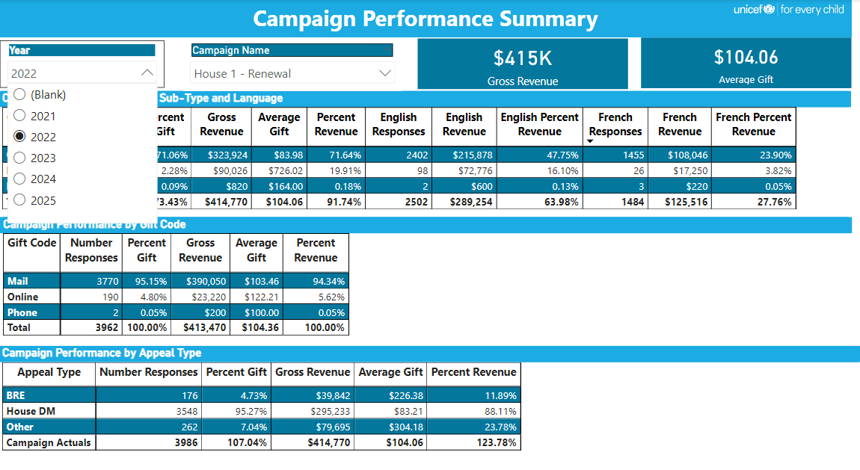

**Measures**

**Static Measures (Specific to 2024)**

Derived from the **Budget** table, these measures remain static for 2024:

* BAverage Gift
* BCost per Piece
* BCost to Raise a Dollar
* BGross Revenue
* BNet Revenue
* BNumber of Gifts
* BQuality e/Mailed
* BResponse Rate
* BROIs
* **TotalCosts** (used only in "Renewal Program Revenue Year-Over-Year by Channel")

**Dynamic Measures**

* Metrics dynamically adjust to reflect the earliest and latest years based on filters applied to the Date column.
* These measures respond to filtering by year or other dimensions.

**Naming Convention**

**Campaign Name Derivation**

Campaign names are derived using a **DAX query** to search for specific keywords in the AppealDescription field. The resulting campaign names are as follows:

|  |  |
| --- | --- |
| **Keywords in AppealDescription** | **Resulting Campaign Name** |
| H1 OR House 1 | House 1 - Renewal Mailing |
| H2 OR House 2 | House 2 - Renewal Reminder |
| Spring Newsletter | Spring Newsletter |
| H3 OR House 3 | House 3 - Malnutrition |
| Summer Newsletter | Summer Newsletter |
| H4 OR House 4 | House 4 |
| Fall FEC | Fall FEC |
| H5 OR House 5 | House 5 |
| H6 OR House 6 | House 6 |
| Giving Tuesday | Giving Tuesday |
| Year End Campaign | Year End |
| *(No match or other keywords)* | Other |

**Maintenance and Updates**

**Data Loading**

1. **Pre-processing**: Remove totals rows or columns to prevent calculation errors.
2. **Validation**: Ensure the data structure of imported Budget and Cost tables aligns with report requirements.

**Relationships**

* Verify relationships between the **Campaign Name** column in the Budget, Cost, and DIM Appeal tables.

**Standardized Naming**

* Ensure column names in DIM Appeal, Budget, and Cost tables adhere to the established naming conventions.

**Step-by-Step Guide to Update the DAX Queries for Static Measures**

This guide walks you through updating static measures (like **BCost Per Piece**) for a new year in the Power BI reports.

**1. Identify the Measure to Update**

* Go to the **Fields Pane** and locate the measure under its respective table (e.g., **Budget 24** or **Budget 25**).
* Click on the measure (e.g., **BCost Per Piece**) to view its DAX formula in the **DAX Editor**.

**2. Update the Table Name**

* Identify the budget table associated with the new year. For example, if the new year is 2025, use the table **Budget 25**.
* Replace the table name in the DAX formula.

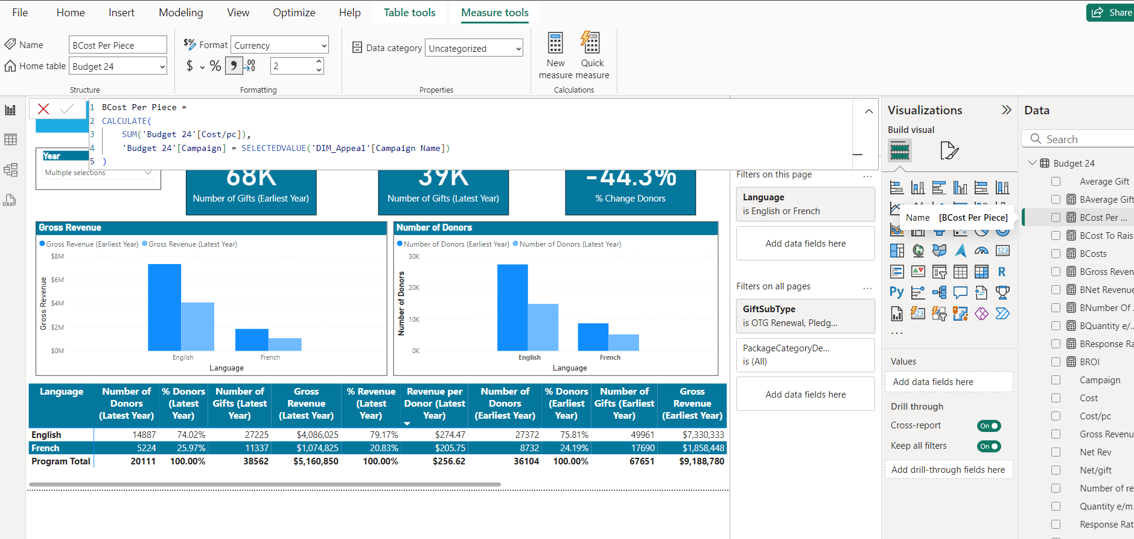

**Updated DAX (2025):**

BCost Per Piece =

CALCULATE(

SUM('Budget 25'[Cost/pc]),

'Budget 25'[Campaign] = SELECTEDVALUE('DIM_Appeal'[Campaign Name])

)

**3. Update Related Measures**

* Repeat the process for all static measures listed below:
  + **BAverage Gift**
  + **BCost Per Piece**
  + **BCost to Raise a Dollar**
  + **BGross Revenue**
  + **BNet Revenue**
  + **BNumber of Gifts**
  + **BQuality e/Mailed**
  + **BResponse Rate**
  + **BROIs**
  + **TotalCosts**

Ensure the correct table for the corresponding year (e.g., **Budget 25** for 2025) is used in each DAX formula.

**4. Validate Campaign Name Relationships**

* Check that the **Campaign Name** in the updated Budget table matches the **Campaign Name** in the **DIM Appeal** table.
* If needed, adjust campaign naming conventions using the documented naming standard.

**Notes**

1. **Future Campaigns**: Maintain naming standards manually in the Budget and Cost tables for any new entries.
2. **Flexibility**: Naming conventions can be dynamically adjusted via the DAX query.